Year 8 Science
Physical Sciences
Revision

Heat Transfer (See Ch. 10.2 of textbook)

1. Copy and complete the table below.

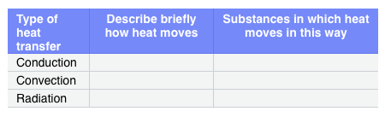

2. What is an insulator? Name three different materials that can act as insulators.

3. Heat can travel through empty space (for example, between the Sun and Earth). How does the heat move?

4. What three things can happen to radiated heat when it arrives at any surface?

5. Conduction occurs in solid materials like metals but is not an effective way of transferring heat in liquids and gases. Explain why this is so.

Sound Energy (See Ch. 10.5 of textbook)

1. What is the cause of all sounds?

2. When compared with air particles in a silent room, how are the particles in compressions and rarefactions different?

3. Explain why sound can’t travel through empty space.

4. If you blow across the top of a straw, a sound is made. How could you increase the pitch of the sound? How do we know, without taking any measurements, that light travels through air faster than sound?

5. Which vibrates more quickly — a long string or a short string made of the same material?

6. Describe what can happen to sound energy travelling through the air when it meets a new substance.

7. Which types of surfaces cause reverberation?

